KENDRIYA VIDYALAYA COSSIPORE
TIME —TABLE FOR PT-1 (VI TO X ) & MT -2 (JULY — 2019 )

VI
VIII
THUR
SCIENCE
s.sc
SCIENCE
FRIDAY
SANSKRIT
HlNDl

MATHS
29/07/19

30/07/19
MATHS
31/07/19
HlNDl
lP
SANSKRIT
SCIENCE
WED
BIO/COMP SC/GEO/B.ST
HINDI
ENG
ENG
HlNDl
TUE
CHEM/ECO/POL SC
MATHS
5.SC
MATHS
SANSKRIT
ENG
MON
MATHS/HINDI
SCIENCE
SCIENCE
s.sc
S.SC
SAT
27/07/19
ENGLISH
ENG
HlNDl
ENG
26/07/19
PHY/ACCOUNTS/HISTORY
S.SC
MATHS
2S/07/19
XII
IX
VII
DAY
DATE

TIMING :- Vl TO VIII --- 8.20 TO 10.20 A.M
lX TO XII ---- 8.20 TO I 1.20 A.M

INSTRUCTIONS:----- 1. All the invigilators shall report to the examination room by 7.55 a.m.
2. Assembly will take place in the class rooms only.
3 Reading time for 1 X —Xl 1 classes ---8.10 to 8.20a.m.
- Interval for classes V1 —V111 &X1—10.20 TO 11.00 am.
- Classes V1 —V1 11 &X1 will have l V Pd from 11.00 to 11.40 a.m.
- Interval for classes I X,X &X11 ---11.20 to 11.40 a.m.
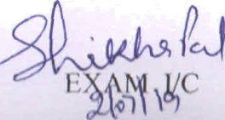
- After 11.40 a.m all the classes will have 5'^{h} ,6", 7'h,&8th pds.
PRINCIPAL

KENDRIYA VIDYALAYA COSSIPORE
DATE SHEET OF PERIODIC TEST-1 (2019-20)
PRIMARY SECTION (FOR CLASSES III TO V)
DATE SHEET
DAY AND DATE | CLASS- III | CLASS-IV | CLASS-V
25/07/19 (THURSDAY) | ENGLISH | ENGLISH | HINDI
26/07/19 (FRIDAY) | EVS | HINDI | ENGLISH
27/07/19 (SATURDAY) | HINDI | MATHS | MATHS
29/07/19 (MONDAY) | MATHS | EVS | EVS

INSTRUCTION:-
1. DURATION OF TEST FOR ALL CLASSESS- 90 MTS.
2. PERIODIC TEST SHOULD START FROM 1ST PERIOD ON THE DAY OF EXAM.
3. USUAL CLASSES SHOULD RUN FROM 4TH PERIOD ONWARDS ON THE DAY OF THE EXAMINATION.

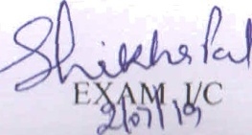
HM PRINCIPAL

